Connecting to CCO Extranet using a personal computer

Step 1
Using your browser, visit: portal.cadets.gc.ca which will bring you to the following page:

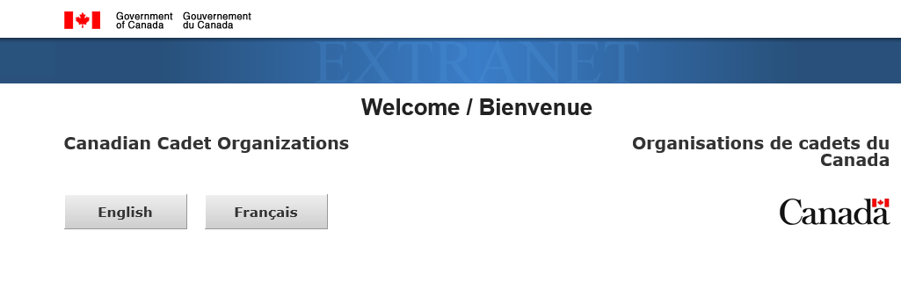
Select your language.

Step 2
Under "Cadet or Parent / Guardian or Sponsor or League Member", click on "Login".
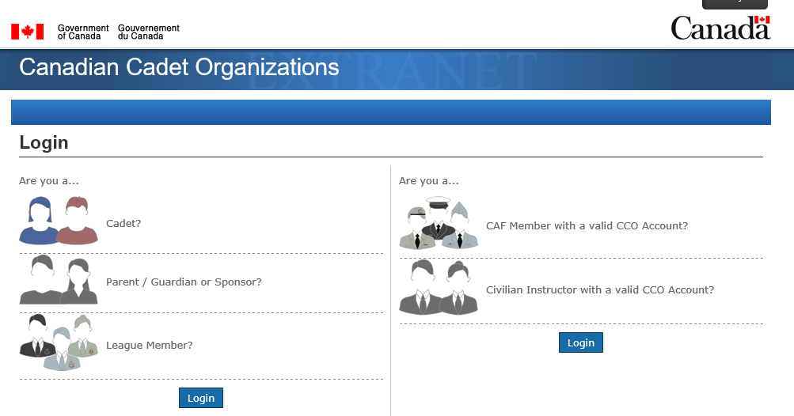
Step 3
Enter your User Name and Password or if you do not have an account Click “Sign Up:” (Note: be sure to remember or record your username & password for future reference)
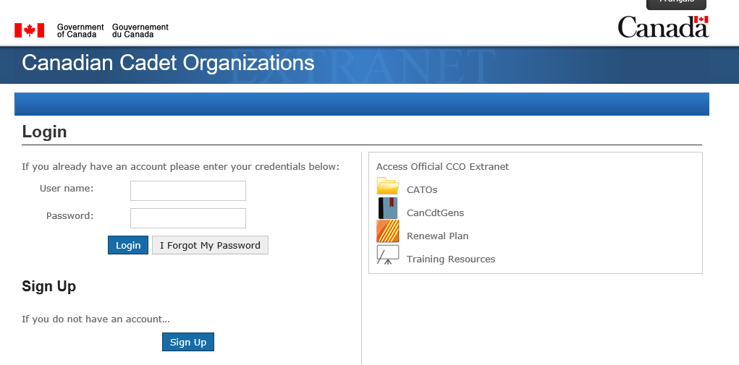
Step 4
All cadets are required to complete the COVID19 Safety Awareness Course. To find this course select the “Civilian Volunteers" tab at the top of the page.
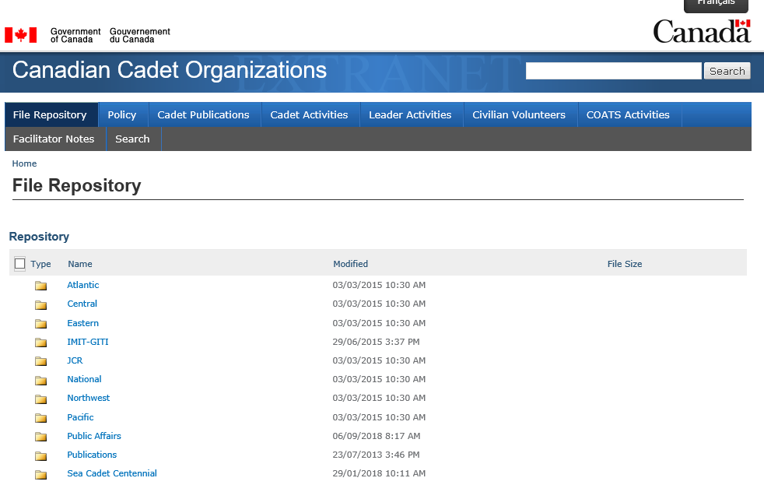

Step 5
Select “Course” at the bottom of this page and complete all slides in this course: Note: THIS COURSE IS MANDATORY FOR ALL CADETS.

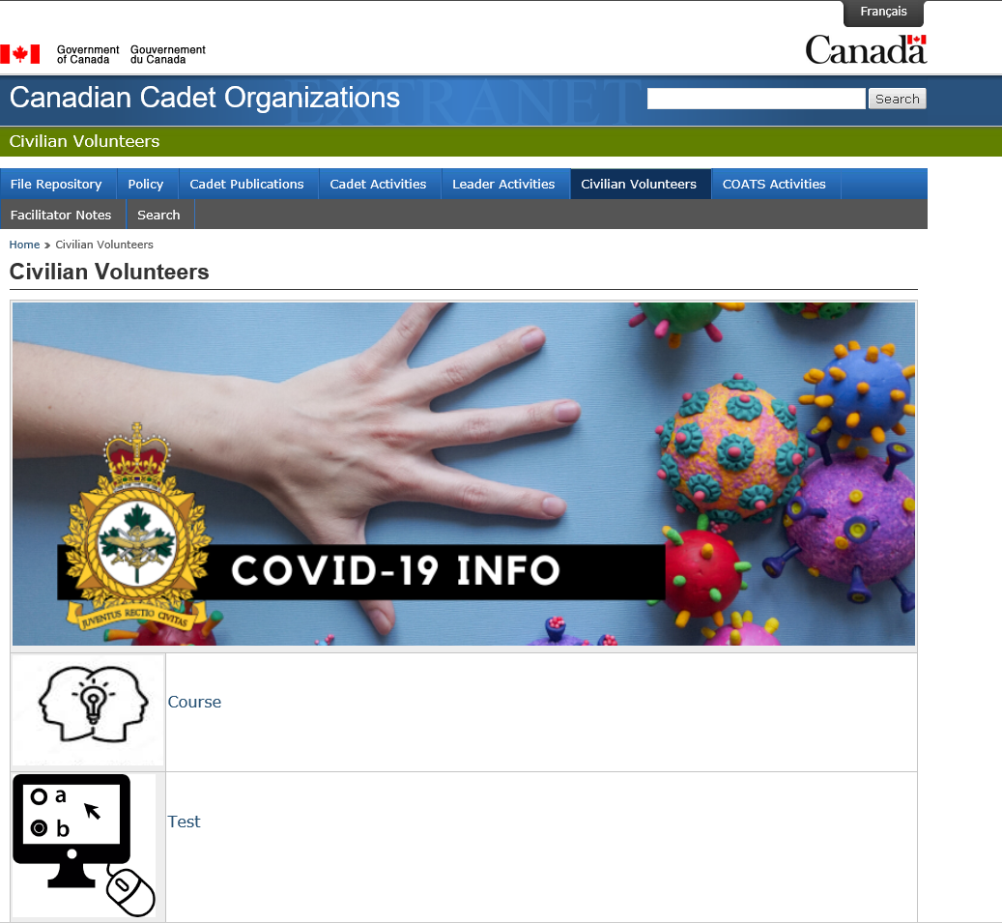

Step 6
Select “Test” at the bottom of this page and complete the test in this course:
Note: When you have completed the course, you will receive a certificate. Save this certificate and email it to 102rcacc@gmail.com as this will be recorded in your cadet training record. THIS COURSE IS MANDATORY FOR ALL CADETS.

Notes:
- The CCO Extranet contains information on Cadet Publications, Activities and other information. Be sure to check this out.
- The COVID19 Safety Awareness Course is mandatory for ALL cadets and must be completed before in-person training is authorized. It is suggested that parents also do this course
- When you have completed the COVID19 Safety Awareness Course and the test cadets will receive a certificate in .pdf format. Please save this to your files and email a copy to 102rcacc@gmail.com.

